Deepfake Detector
  - Prediction of Kaggle Dataset evaluation:
This model uses EfficientNet-B0 architecture fine-tuned for deepfake detection. It can analyse both images (.jpg, .jpeg, .png) and videos (.mp4, .mov).
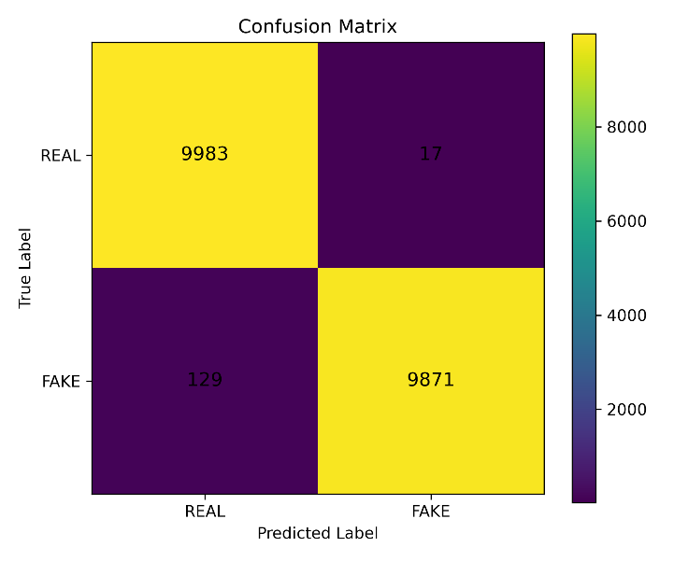
Overall, approximately 99.3% of predictions are correct. It has a 98.7% recall rate, which means it successfully catches 98.7% of all actual “FAKE” cases. The model is highly precise which is crucial in real world use-cases such as social media moderation or even in the political landscape.
Real images that were not predicted correctly had a tendency to show lighting that was not natural. The images were well-lit, but lighting seemed to come from flashes or other artificial lighting. While there exist images that were correctly predicted as real with such lighting, this was what was observed for the falsely categorised real images.
Fake images that were incorrectly classified had a non-negligible number of images with backgrounds that were completely white or almost completely white. An example is included as Picture 1 in the Appendix. A completely white background removes texture, edges, and environmental cues. It could interpret the unusual background as “real” because it doesn’t match the fake artifacts learnt in training.

  - Prediction of self-sourced AI generated images evaluation:
  - 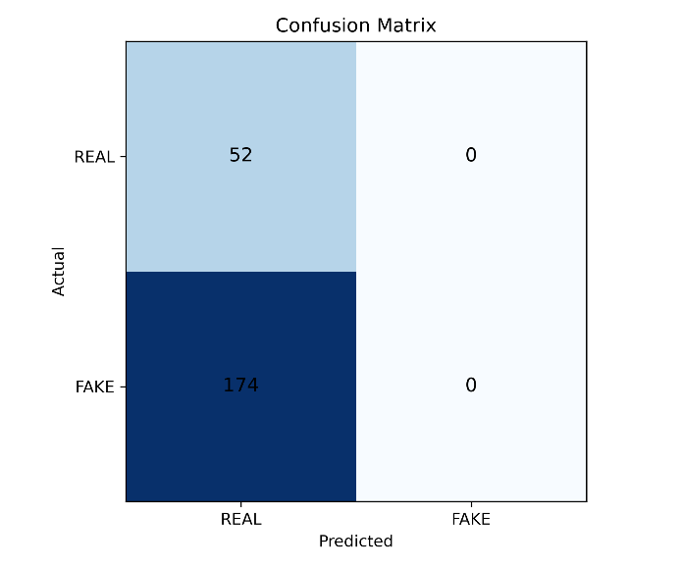
While this model performed well for the Kaggle dataset, it fails completely at identifying AI-generated images from the various models where a human face is not the focus of the image.
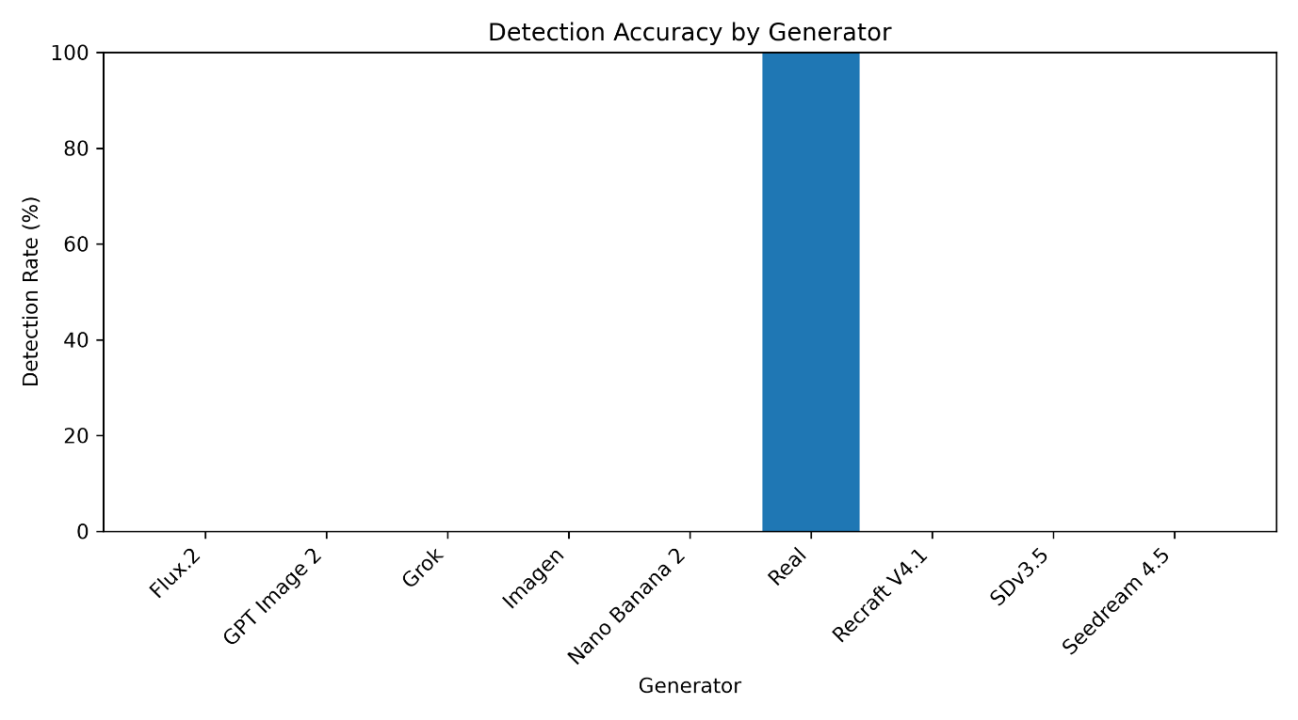
Although it correctly classifies all images as real, it completely ignores the class of AI-generated images and provides no meaningful discrimination between real and AI-generate images.
This model is overfitted to facial features and lacks generalisation to other contexts. It is highly likely that this is attributed to the model being trained mostly with data focusing on human faces. The datasets recommended for training the model in the original repository included high-quality celebrity deepfake dataset, Facebook's large-scale deepfake detection dataset and other datasets with a focus on human faces. Hence, the model struggles to pick up reliable signals when predicting images in the self-sourced data set. It defaults to predicting “REAL” for everything.

AI-Generated-Video-Detector
  - Prediction of Kaggle Dataset evaluation:
This model uses deep learning techniques like EfficientNetV2 as a core model for image and video classification and MTCNN for face detection in images and videos. The model was trained using TensorFLow.
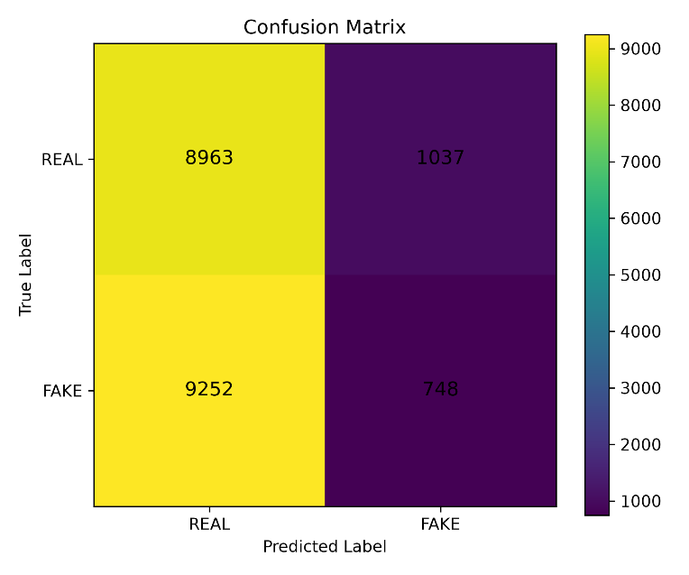
Only 48.6% of predictions are accurate, which is almost as good as chance and the model has high recall for real (89.6%) but extremely poor recall for AI-generated (7.5%). The model is biased towards predicting that images are real.

  - Prediction of self-sourced AI generated images evaluation:
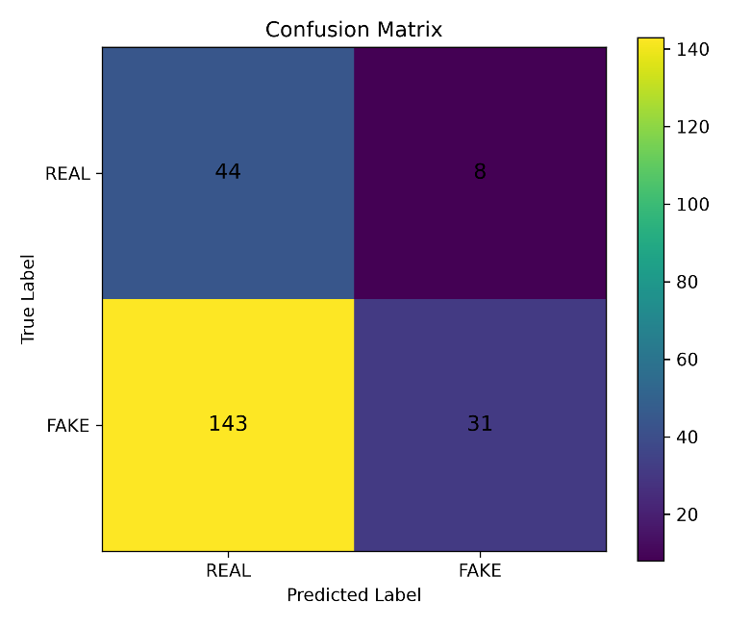
Similar to the Kaggle dataset, the results show that the model is biased towards predicting that an image is real. The accuracy rate for images with faces not as the focus is even lower at 33.2%. The recall rate for real images is 84.6% and 17.8% for fake images.
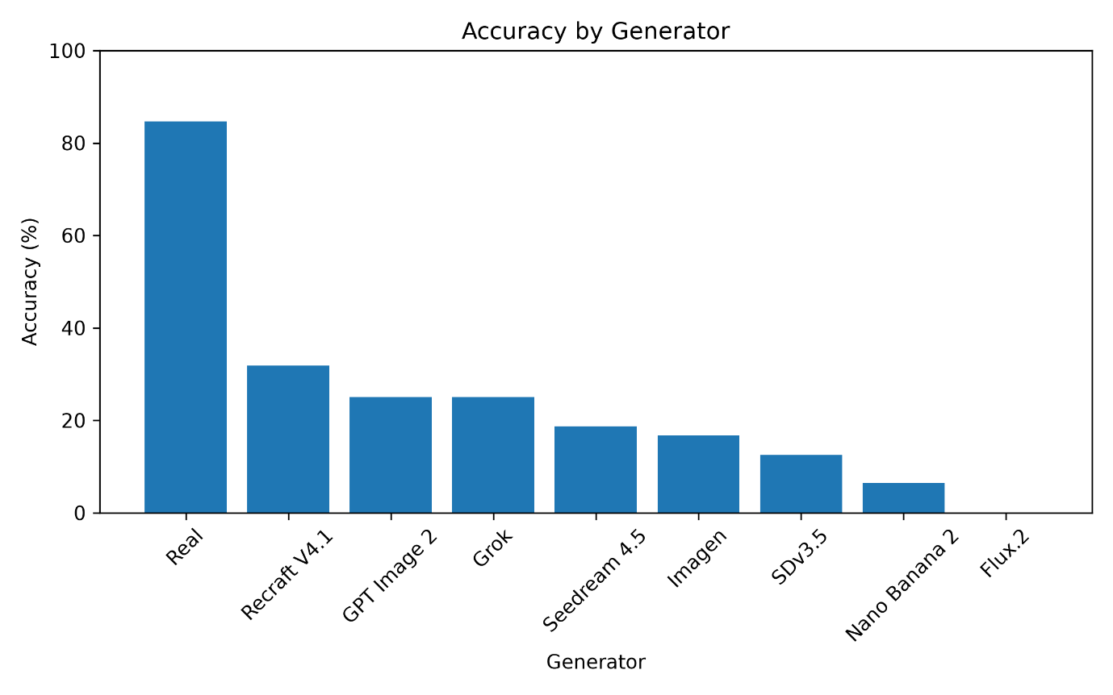
This graph also shows that the accuracy of classification for real images far outweighs that of AI-generated images from each model. From this graph, generator producing images with the highest rate of misclassification is Flux.2 with all 9 images predicted as real. The generator producing images with the lowest rate of misclassification at 15 misclassified images is Recraft V4.1.
The model's performance on the real class is misleading when considered in isolation as it is possible that the model is simply unable to classify real and AI-generated images rather than successful classification of real images. It may simply default to classifying images as real.
However, the difference between the prediction results for the Kaggle dataset that has faces as the main focus and that of the self-sourced dataset with faces not as the main focus is not as drastic as Deepfake Detector model even though both use EfficientNet architecture.

Facetorch
  - Prediction of Kaggle Dataset evaluation:
This model uses a combination of RetinaFace, EfficientNet-B7 and MobileNetV2 for image classification.
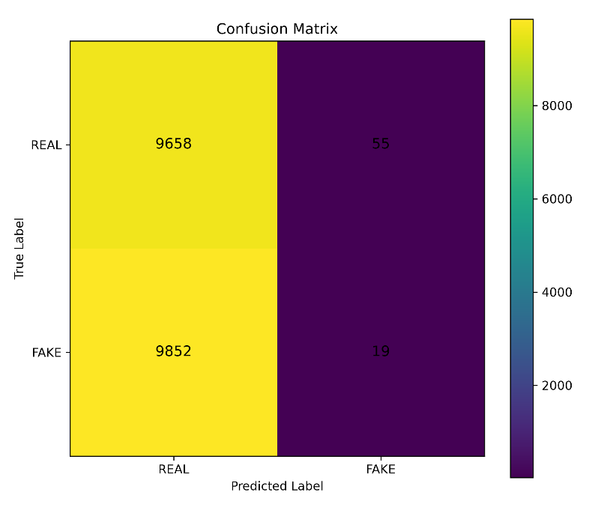
With an accuracy of 49.4% and recall rate of 99.4% for real images and 0.19% for AI-generated images, there is a severe bias towards predicting images as real. The results is similar to that of the AI-Generated-Video-Detector, which may be due to EfficientNetV2 being used in both models.

  - Prediction of self-sourced AI generated images evaluation:
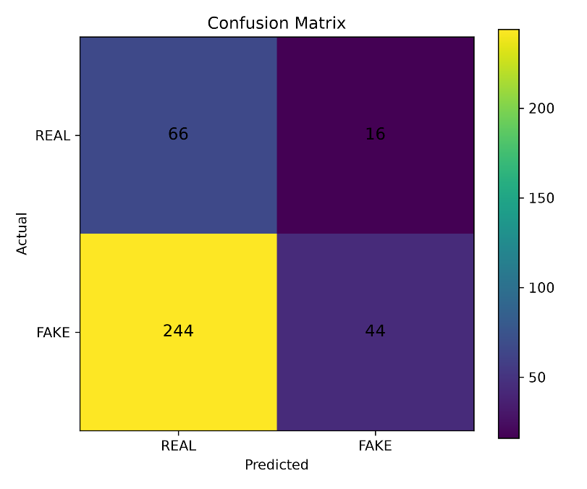
The prediction results for the self-sourced dataset shows 29.7% accuracy, real recall rate of 80.5% and fake recall rate of 15.3%. This is like the prediction results for the Kaggle dataset.
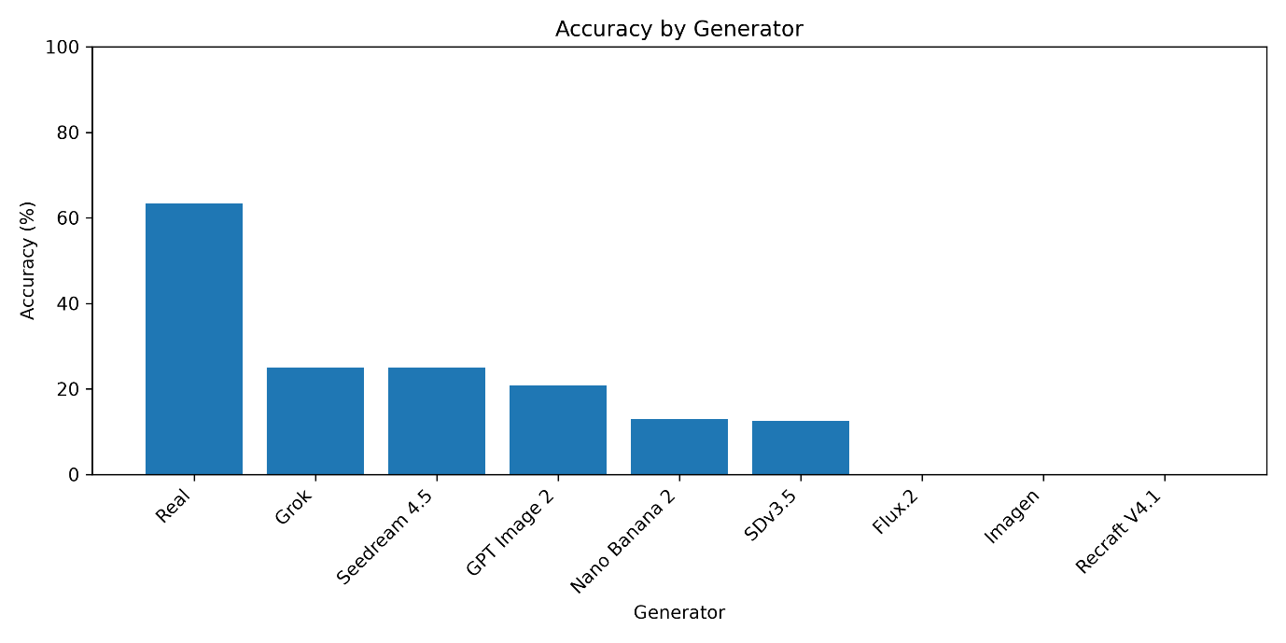
Similarly, the accuracy of classification for real images is higher than that of AI-generated images from each model. Flux.2, Imagen and Recraft V4.1 generated images were all not correctly classified by the model. Grok and Seedream 4.5 produced images that had the lowest rate of misclassification.
Across all categories in the self-sourced dataset, this generator underperformed relative to the AI-Generated-Video Detector, despite being a combination of three models compared to the detector’s use of just one. While the three models are technically compatible in a pipeline — detection, alignment, and classification — their combination did not yield performance gains. This suggests that the integration strategy, rather than incompatibility, may explain the underperformance.

Overall comparison
The first model performed the best for the Kaggle Dataset with a high rate of accuracy while the other two models both had accuracies below 50%, worse than random guessing.
All three models did not perform well in classifying images in the self-sourced dataset. They were all biased towards classifying images as real. The first model was the worst, classifying every image as real, followed by the third model then the second.
It is interesting to note that across all 3 models, none of the models correctly classified any image generated by Flux.2. Flux.2 is the only model that uses transformer hybrid in combination with diffusion for image generation. The generation methods of the other models can be found in the appendix.

Conclusion
Overall, only the first model, Deepfake Detector is close to being ready for employment for real-world cases of classifying faces as real or AI-generated. The other two models need significantly more training. All three models, however, are nowhere near to being ready for classifying images that are not focused on human faces as they have a severe bias of classifying them as real.
Future AI-generated image detection models should be trained to recognise not only human facial features but also broader image-level characteristics and generation artifacts. As generative models continue to produce increasingly photorealistic images, facial features alone are no longer reliable indicators of authenticity. Learning a wider range of discriminative features, including inconsistencies in textures, lighting, shadows, reflections, backgrounds, and frequency-domain patterns, can improve a model's robustness and ability to generalise to images generated by improving AI models. Additionally, the risks of synthetic media extend beyond facial identity manipulation. AI-generated images of places, objects, or events can be used to create false narratives such as military activity that did not take place or a manipulated image of a company’s product.
Nonetheless, it is interesting to note that the diffusion and transformer hybrid generation method had 100% misclassification rate across all 3 models.
While there are many more deepfake detection models out there, this sample proves not to be an effective solution for use cases. More effort for model improvement and training is required in this evolving landscape of synthetic media generation.

Proposed improvements for future works
For future studies, the identified models should be trained on the same dataset for a more unbiased comparison on their prediction performance. They should also be trained using a mix of images that focuses on facial features and those that focus on objects or scenes where faces may not even be present.
To better understand the type of generation method that causes models to misclassify images the most, more models need to be tested, and a higher volume of data is required for the self-sourced dataset. As this project is limited by the number of images that can be generated by each model in their individual free plan, it is also plausible that the generators that caused the most severe misclassifications was by chance due to the small dataset size and insufficient diversity in models.

Appendix

Picture 1:


Models and their Generation Methods
